SATURDAY, AUGUST 22, 2009 | BREAKING NEWS VANCOUVERSUN.COM
TECHNOLOGY
ID-scanning to comply with privacy laws
B.C.'s privacy commissioner works out compromise for method used in bars and clubs
BY DAVID KARP
VANCOUVER SUN
Controversial technology that collects bar patrons' personal information will remain in use after B.C's privacy commissioner worked out a compromise with the technology's owner.
Privacy commissioner David Loukidelis ruled in July that a system made by TreoScope to collect and store customers' names, photos, birthdates, genders and driver's licence numbers as part of the BarWatch program violated privacy laws.
But on Friday, he said the software can remain in bars and clubs providing it does not retain the driver's licence numbers, and erases data within 24 hours after it's collected.
However, bars will be able to keep the information of violent customers in the system and share that data with other establishments.
"There was too much information being kept on everyone for too long, so you're building profiles of all customers over time and retaining them," Loukidelis said in an interview.
"Now, we're collecting much more restricted information, and keeping it for more than 24 hours only on the bad guys."
Loukidelis said he tried to strike a balance between safety and privacy in deciding on the 24-hour time limit.
One of the benefits of keeping personal information for longer periods of time is that it makes it easier for people who are victims of crimes such as sexual assault to identify perpetrators after the fact.
"There are any number of other offences where there could be investigative value in keeping the data longer, but the cutoff had to be somewhere that it was enough to deal with immediate incidents of violence and threats to customers, which was the main pressing concern as I saw it, without keeping the information for too long," Loukidelis said.
Owen Cameron, the owner of TreoScope, said he called the privacy commissioner the day after his decision to talk things through, and has spent the last month scouring Loukidelis' original decision.
"I basically sleep with it under my pillow," Cameron said. "You start to read it a few times and go, 'Hold on, what is he actually saying here?' And when I started to do that, I started to realize this isn't as harsh as one might first read."
Cameron said he consulted with bar owners who use the technology, and found there was no reason to hold on to information for more than 24 hours or retain driver's licence numbers.
"[Bar owners] never saw the driver's licence number, and quite bluntly, they all said, 'We don't care if it disappears within 24 hours. We used it to identify people we didn't like,'" Cameron said.
dkarp@vancouversun com

F THE B C PRESS COUNCIL
EDITORIAL
Kevin D. Bent President and Publisher Wayne Moriarty Editor-in-chief Ros Guggi Deputy Editor Fabian Dawson Deputy Editor Paul Chapman Senior News Editor
-The Province is published by Pacific Newspaper Group, a division of Canirest Publishing Inc | 20O Granville St, Vancouver, B.C. V6C 3N3| Newsroom 604-605-2063 • Editorial fax 604-605-2099
MONDAY, AUGUST 10, 2009
S COLONIST EDITORIAL
gets HSTerical
ened to open, honest government?
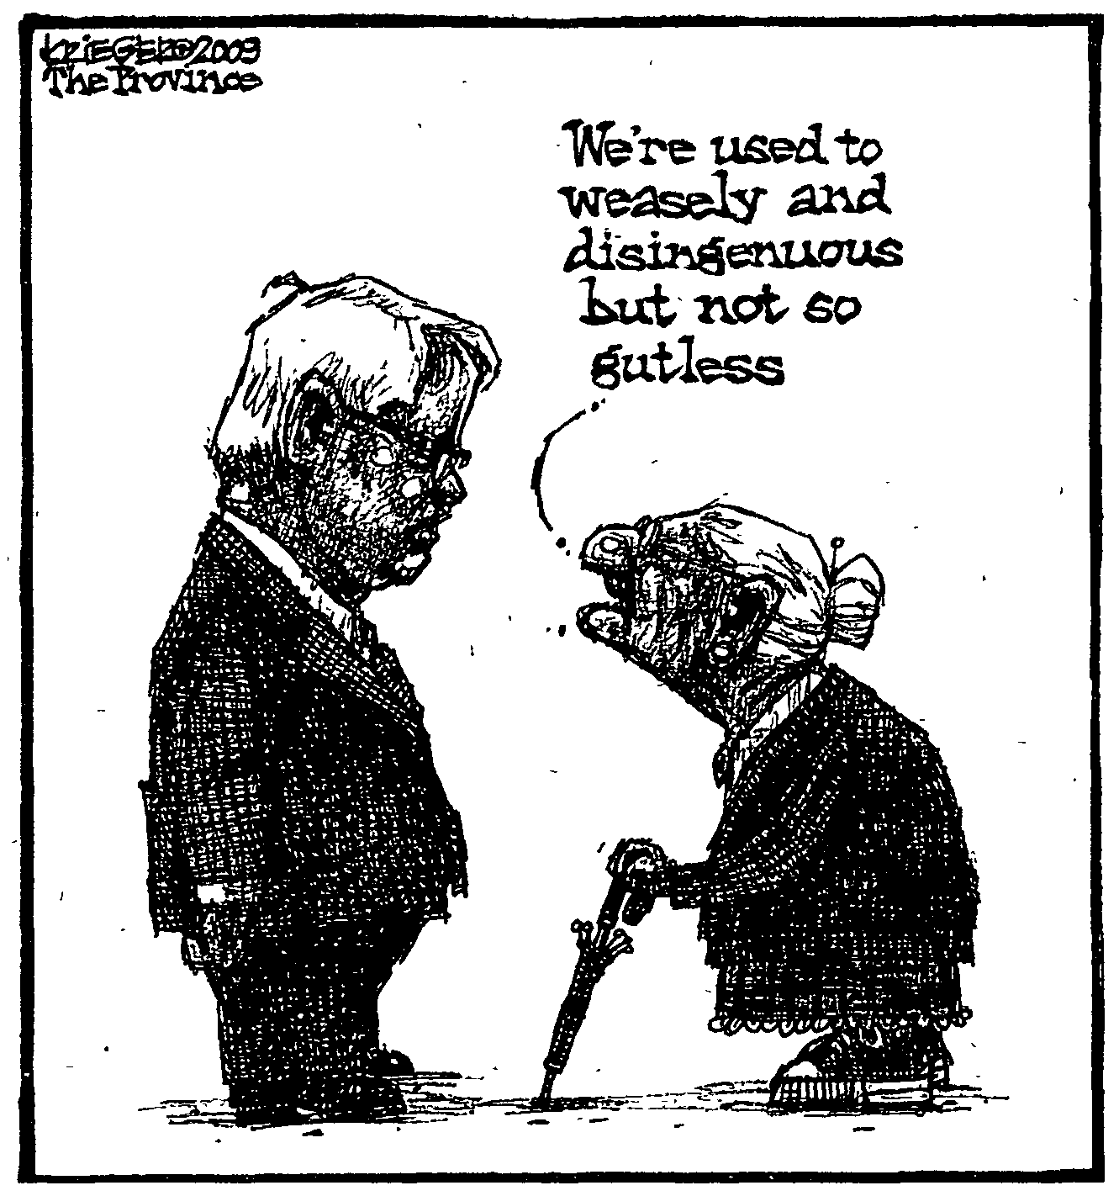
ite the economy. Eight ears and two elections iter, the tune has hanged — because now, inance Minister Colin lansen says, the HST is the single biggest thing e can do to stimulate e economy." Hansen's argument is ased on the notion that usinesses will pay 1.9 billion less in taxes ecause they will be able claim back the tax they ay. In theory, this will sult in lower prices, and onsumers will benefit. fe will need to see what appens on that point. In the short term, however, the government is fting money from the allets of individuals, nd handing that money business interests.
A sales tax is efficient, in that it is hard to cheat. But it is also regressive, as lower-income individuals pay the same rate as those in the higher income brackets. The tax shifts more of the burden on to those less able to pay.
Hansen swears the tax was not on the radar during the election campaign and the announcement two weeks ago was based on discussions held since the May 12 vote.
That is disturbing, and not just because the premier specifically said before the election that his government would not introduce the HST.
It defies belief to believe the tax went from nowhere to announcement in less than 10 weeks. We are left with two choices: Either the government was working on it before May 12, or it rushed the tax in with lit-de preparation. Either way, the province loses — and the credibility of elected officials takes another body blow.
Voters were misled about the tax increases. The government has admitted that the $495-million deficit called for in its budget will actually be much higher, despite campaign claims that the number was firm.
And the Liberals didn't mention coming cuts to programs and grants during the campaign; in fact, they did what they could to ensure the information
did not get out.
The province will get $1.6 billion from the federal government as an incentive to make the tax switch, money that will help it come closer to balancing its own books.
All that said, the arrival of the HST is more evidence that our political system is ailing.
In February, Hansen delivered a budget that was so heavy on optimism that it was challenged almost immediately. It took the minister several months — until safely after the election — to admit that the critics were right.
During the campaign, the Liberals said they were against the HST and did not talk about the impact of the severe economic downturn. Their election platform, which does not mention the new tax, must be dismissed as irrelevant and inaccurate.
So we can't believe the budget, and we can't believe the election platform. Could it get worse than this?
Well, yes. As annoying as it was that the public was not consulted about the HST, the government made a mockery of the democratic process by announcing the tax increases, without any consultation, when the legislature was not sitting. Why do we have all those MLAs, anyway? Why did we have an election, if the only purpose was to choose some people who will have no say in how the government is run?
Campbell promised years ago that he would run an open, honest government. The HST is just the latest announcement to make a mockery of that promise.
Google must do better
The following editorial appeared in Saturday's Washington Post:
What is Google Book Search? A library? A bookstore? Or something else altogether?
Some call it Alexandria 2.0, and the comparison with the great library of antiquity is apt. Google has digitized millions of books, and if its proposed class-action settlement with their authors and publishers passes muster, these books — formerly the province of college libraries and research institutions — will be available to everyone. Google began digitizing books without the permission of copyright holders, claiming fair use. This provoked a class-action lawsuit on the part of authors and publishers, resulting in a settlement that offers many boons for the public. Books in the public domain will be free, and those still under copyright will be available in a standard 20-per-cent preview. Google will also provide free access to the entire repository at nearly 20,000 libraries, only charging fees to print.
What about books still under copyright whose owners have not been located — so-called "orphan" books? Google's claim makes sense: Many rights holders will emerge once they see that their work has value, but it is also in the registry's charter to seek out these rights holders. As Google Book Search generates revenue for content creators, the owners of all but the least-accessed, least-valuable books will probably come forward.
So it's curious that Google felt the need to include a clause in the settlement to prevent the registry, negotiating on behalf of "orphan" books, from offering a better deal to any of the company's competitors within its first 10 years. Google's argument is that it performed a public service by setting up the registry and investing millions of dollars. But if the set of protected books encompasses only those so valueless that no one will claim them, it is baffling why protection from competition is needed.
Google's innovative efforts will enhance the world's access to knowledge, but that doesn't mean it should have it both ways. Its settlement is in many ways better for consumers than the possible outcome of litigation. But the fact that what Google is doing is wonderful should not preclude the potential to do better.

